

**DATE:**

**17/06/2024**

**CLASS:**

**OOP -14541**

**WORKSHOP TOPIC:**

**REVERSE ENGINEERING**

1 ACUÑA GAMBOA CHRISTIAN MARCELO

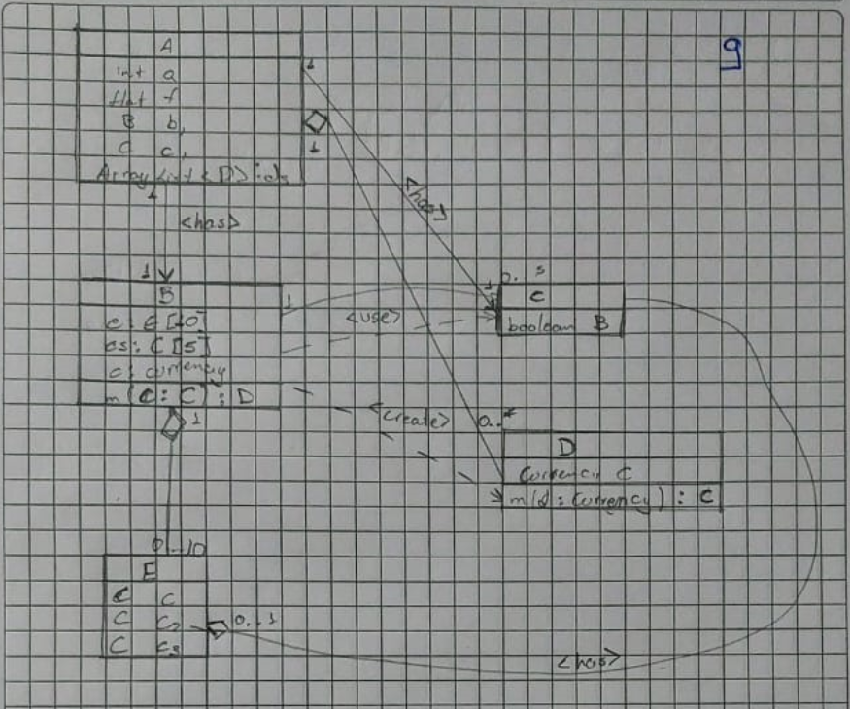

2 ARBOLEDA ROMAN ABNER DAVID

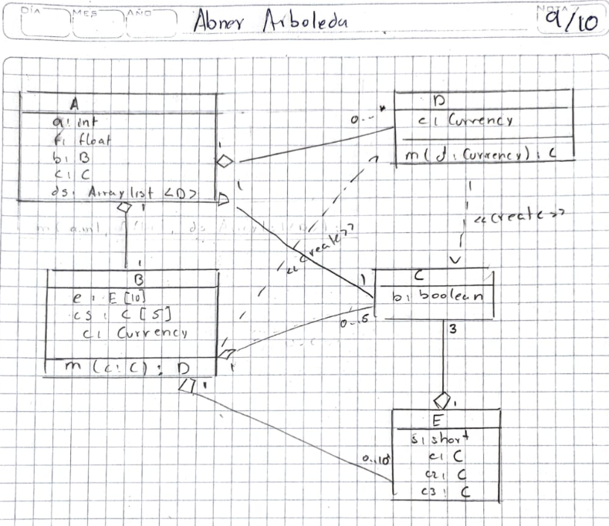

3 ARMIJOS MACAS ENZO ALBERTO

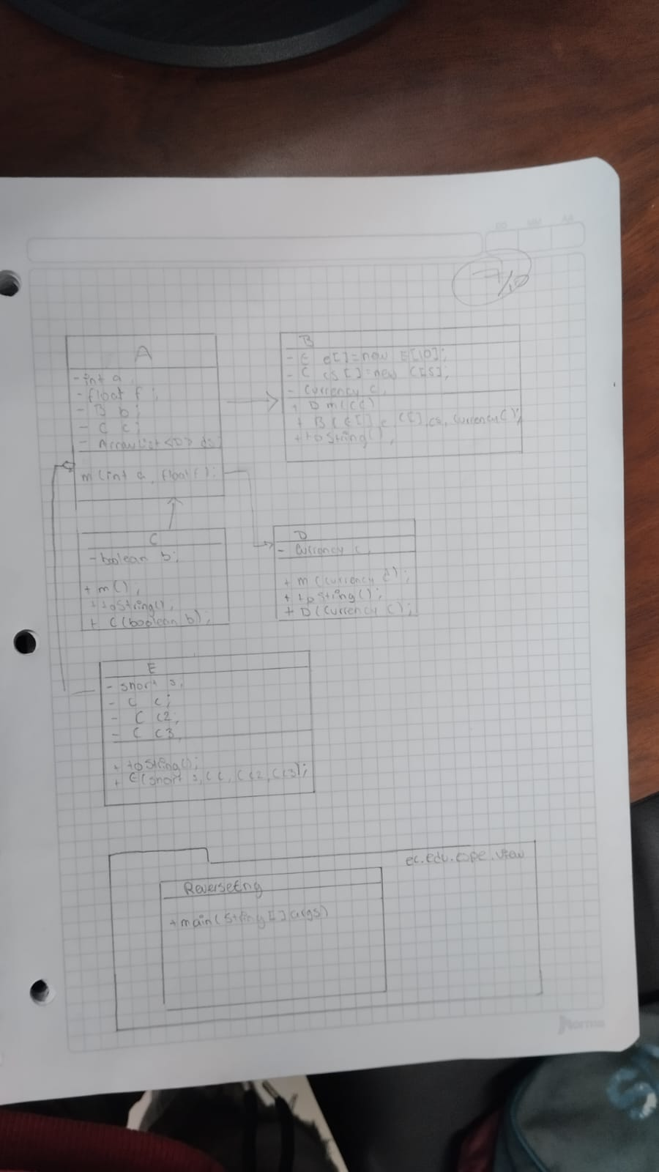

4 AYUQUINA NAVAS DANNY MATEO

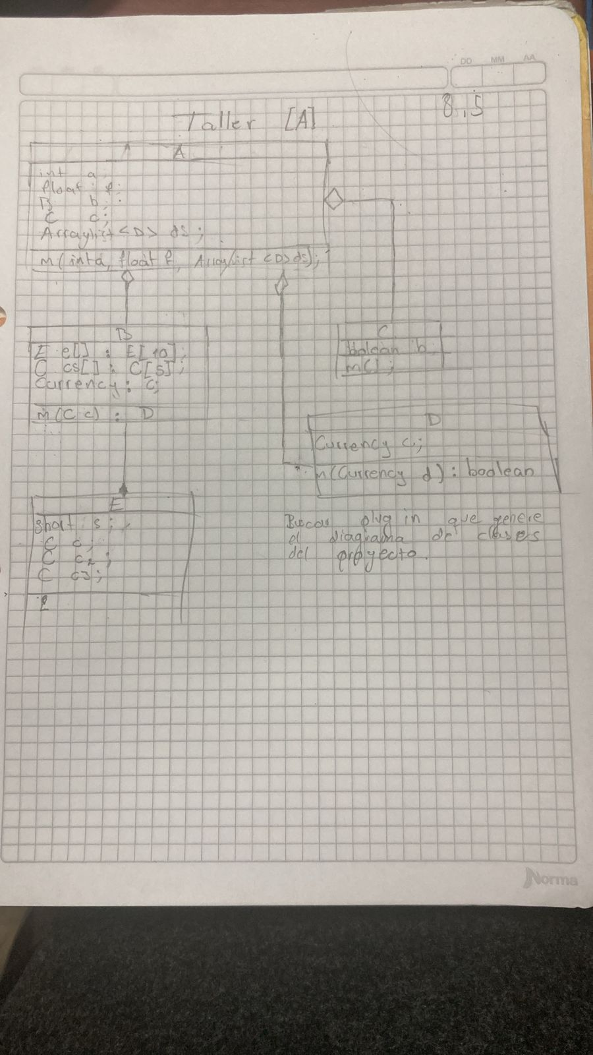

5 BONIFAZ VASQUEZ CHRISTIAN MATEO

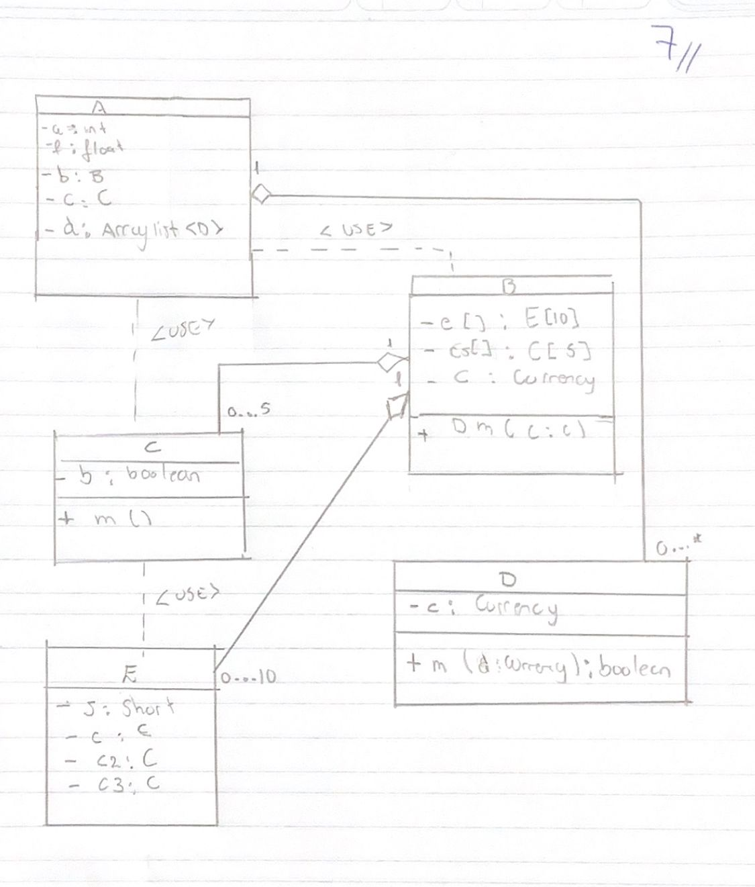

6 CAÑARTE GALARZA SARAY ADRIANA

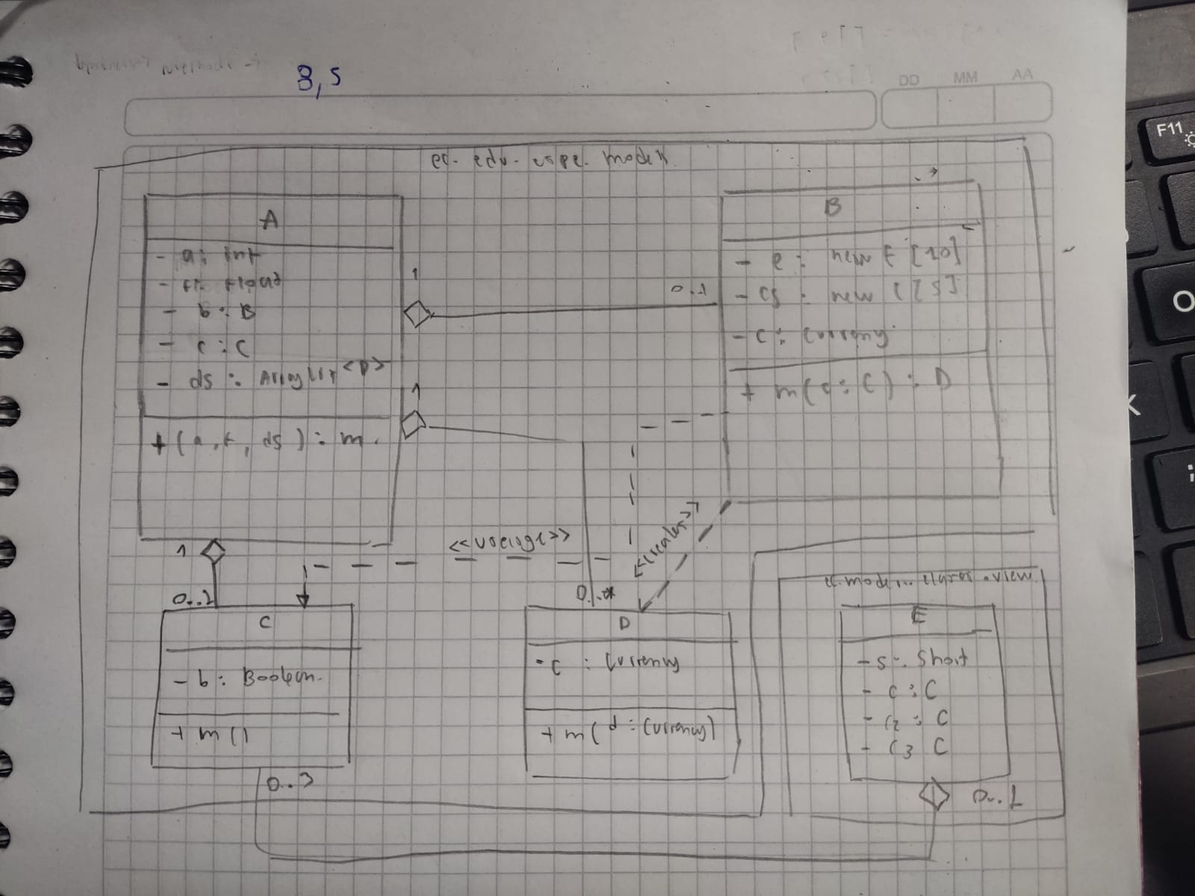

7 CEDEÑO CUENCA ANDRES ISAIAS

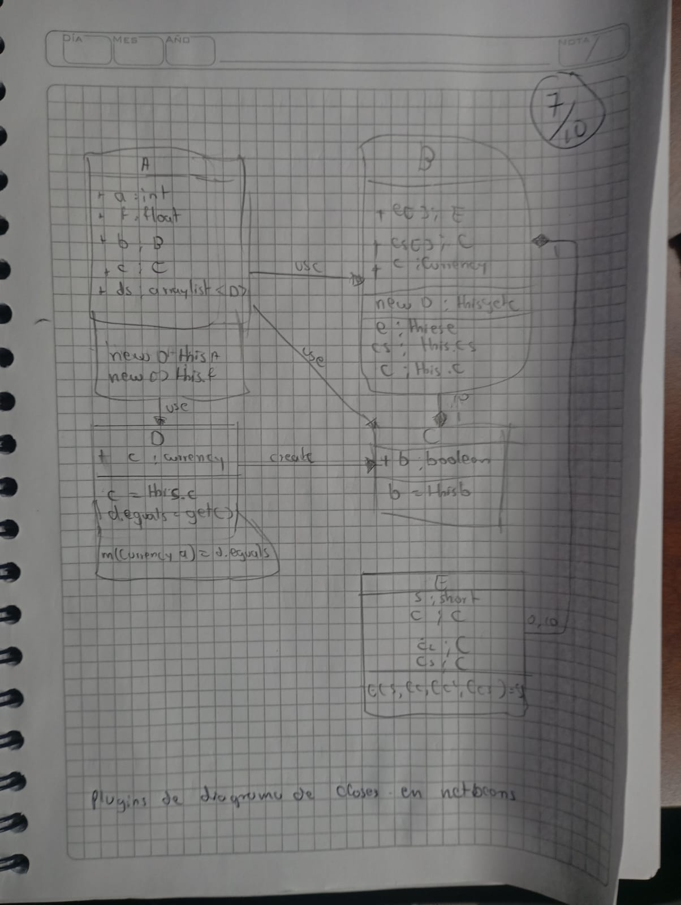

8 CEDEÑO REYES NAHOMI NAYELY

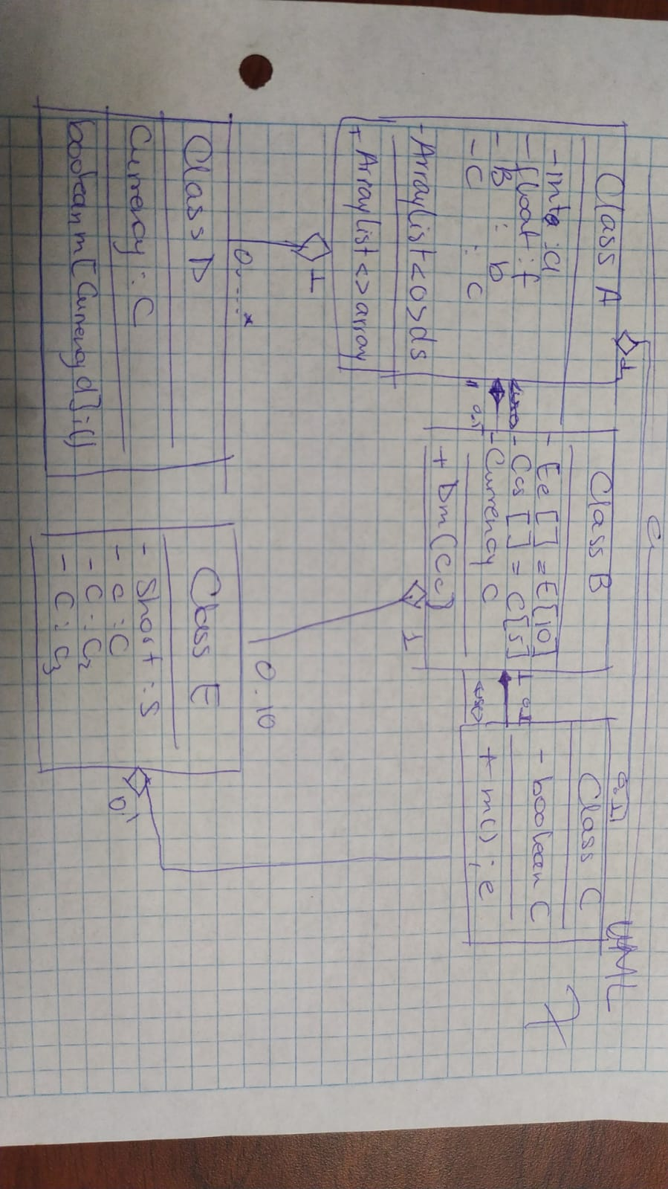

9 CHANATAXI QUIMBIAMBA MARCO VINICIO

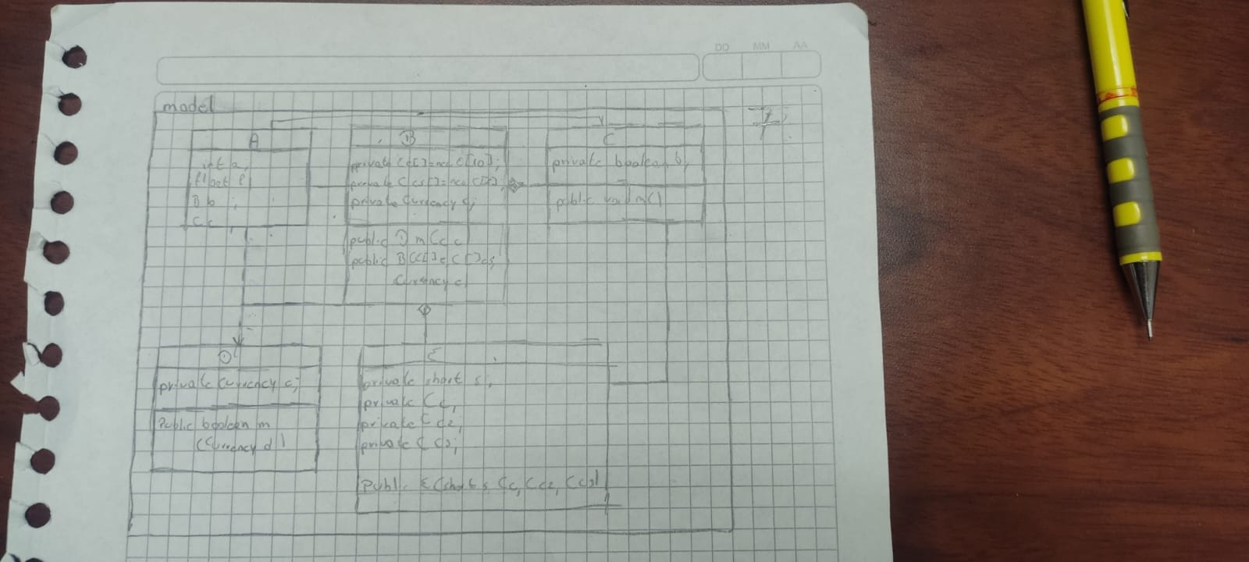

10 GAVILANEZ OCAMPO KENNY JESUS

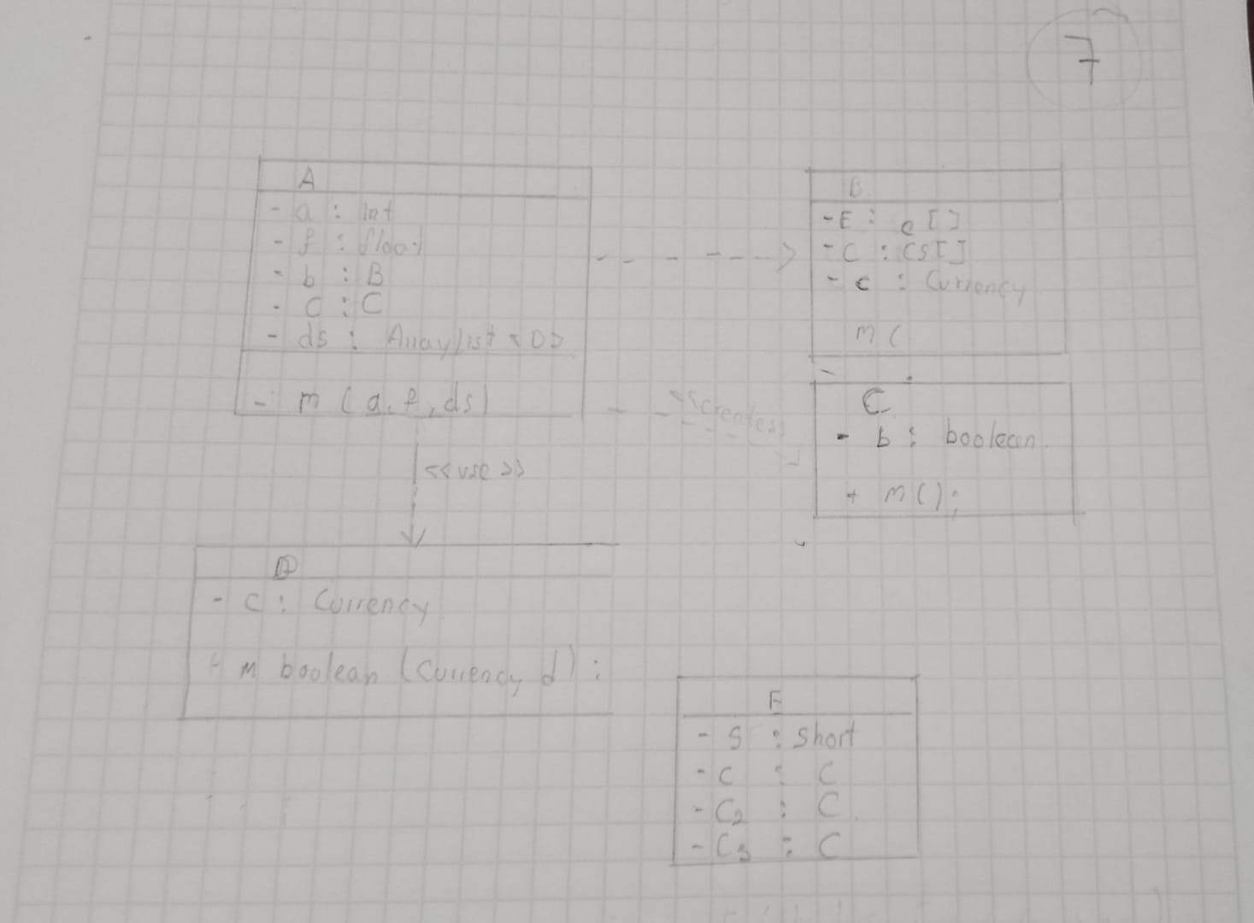

11 GUALOTUÑA AMAGUAYA BRAYAN PATRICIO

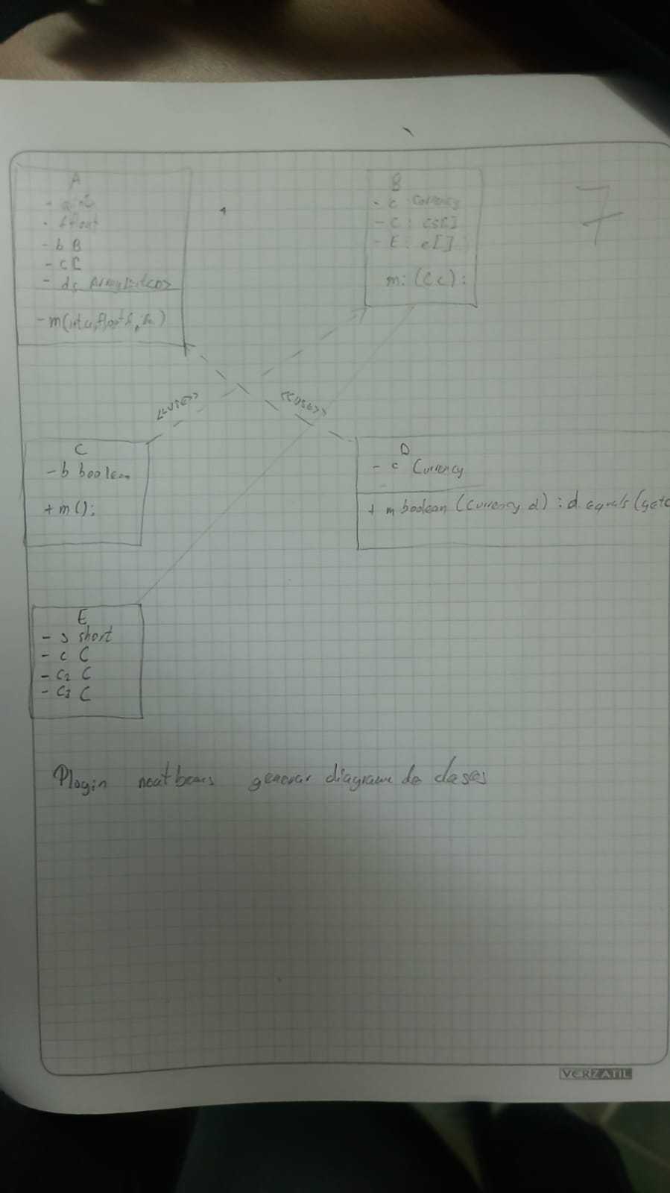

12 LISINTUÑA CORREA CRISTIAN MATEO

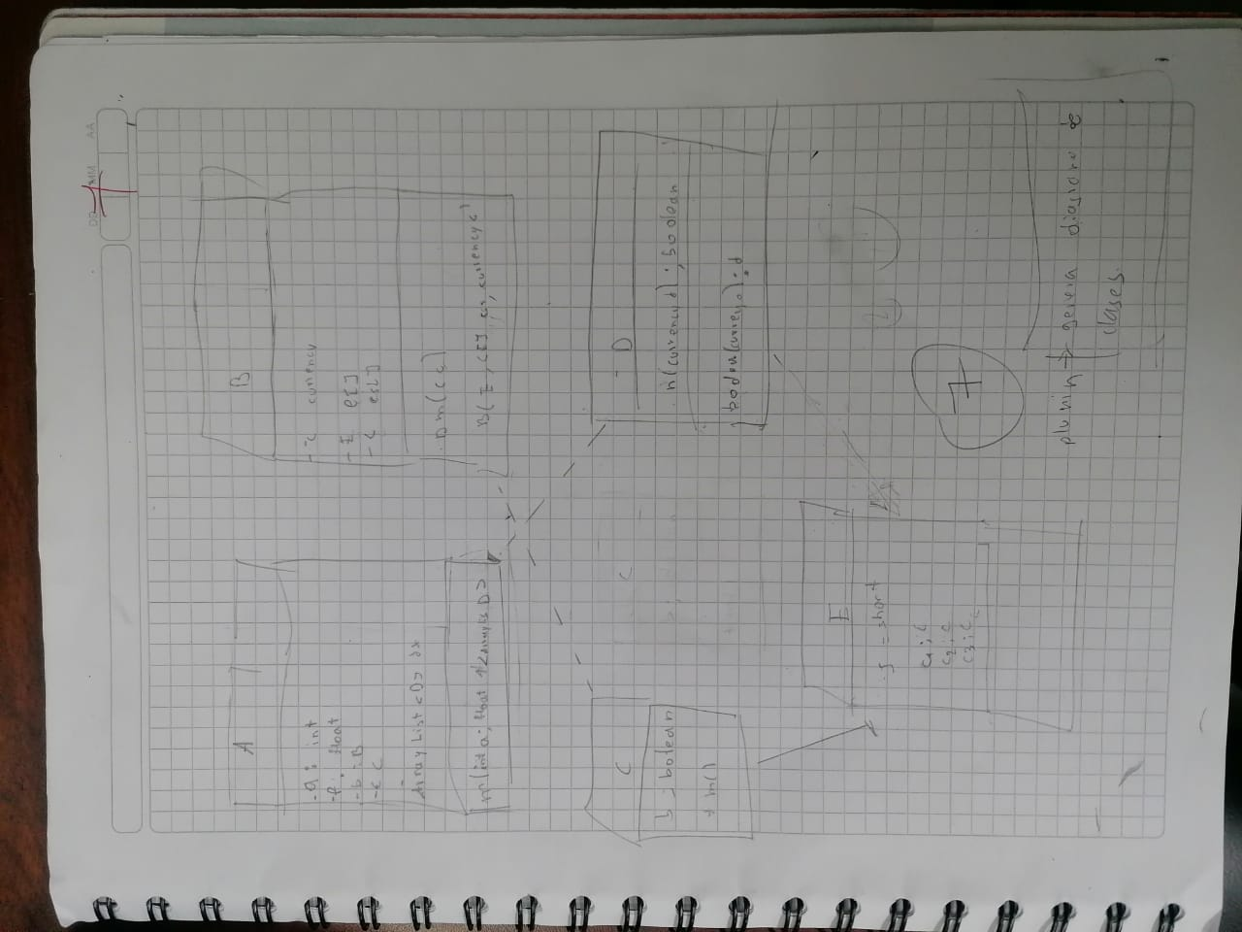

13 MARQUEZ QUIROZ JENNIFFER PAOLA

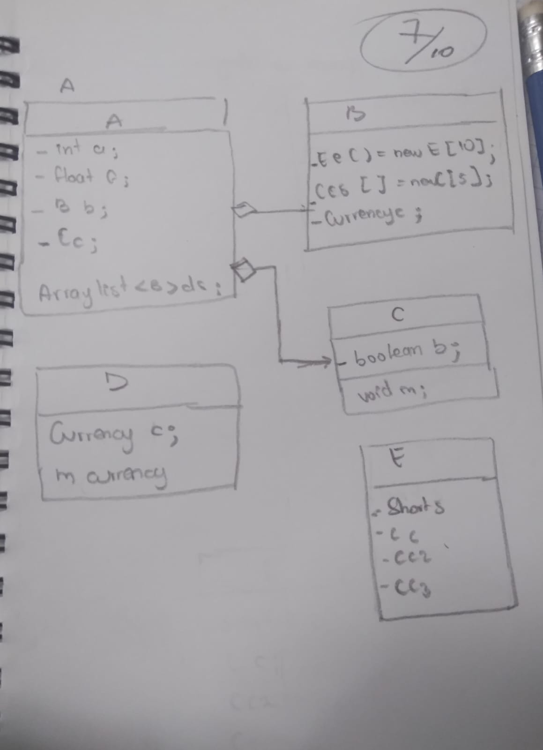

14 MEDINA AUQUILLA NATHALY SIMONE

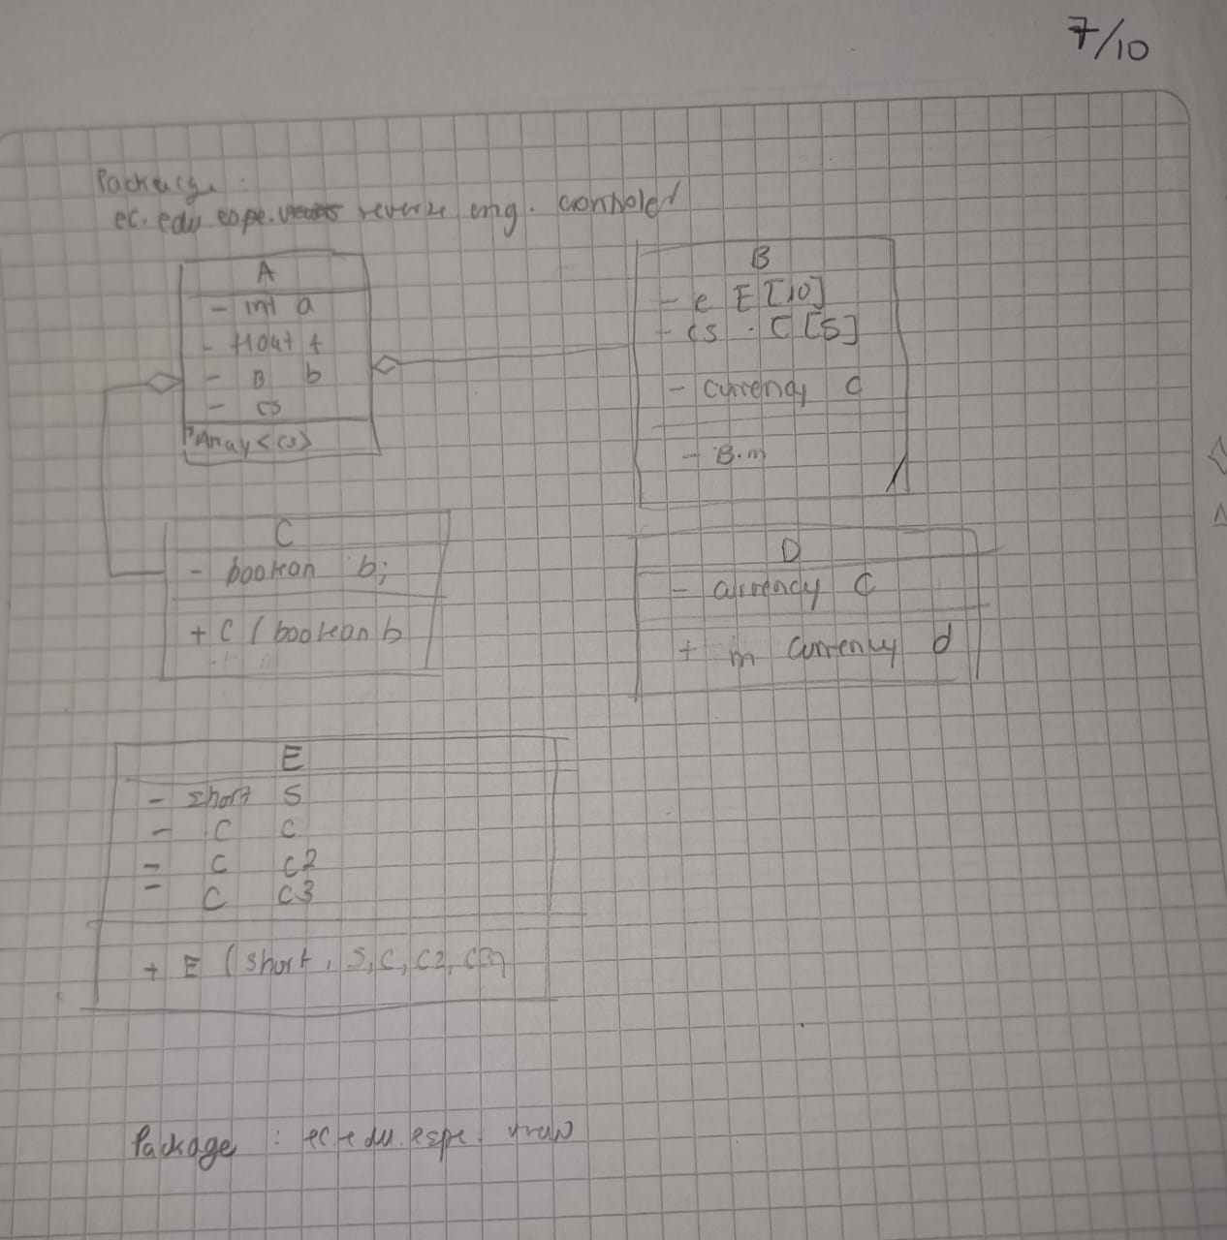

15 MORILLO CUEVA DAVID ARIEL

16 PANTOJA JIMENEZ CARLOS DAVID

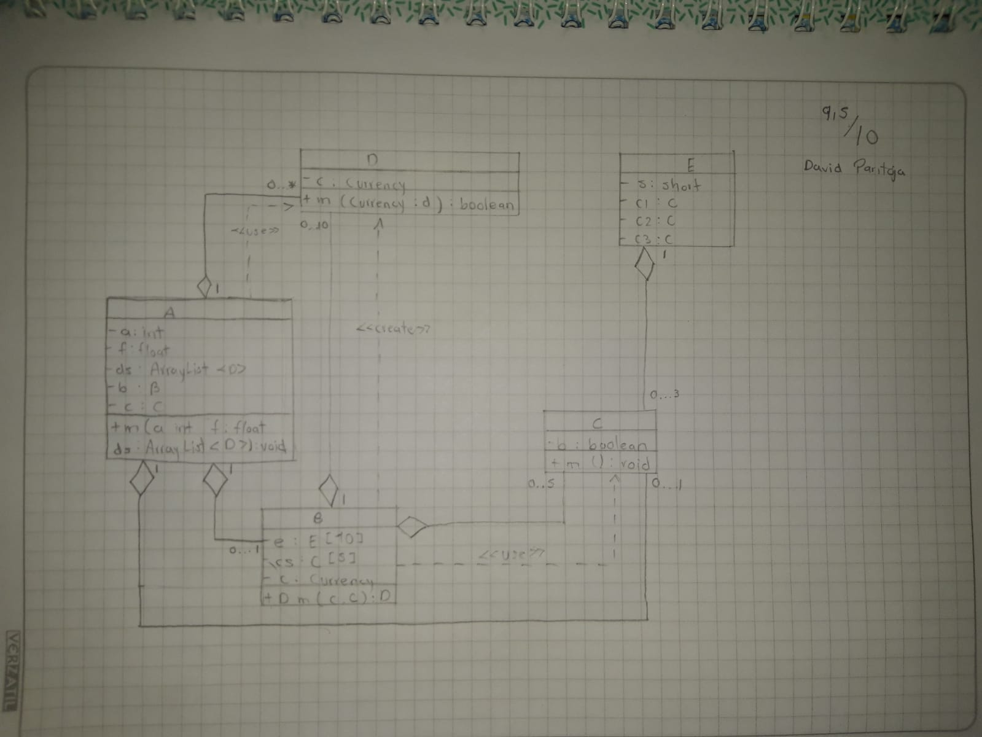

17 PEREZ CONDOR CARLOS ANDRES

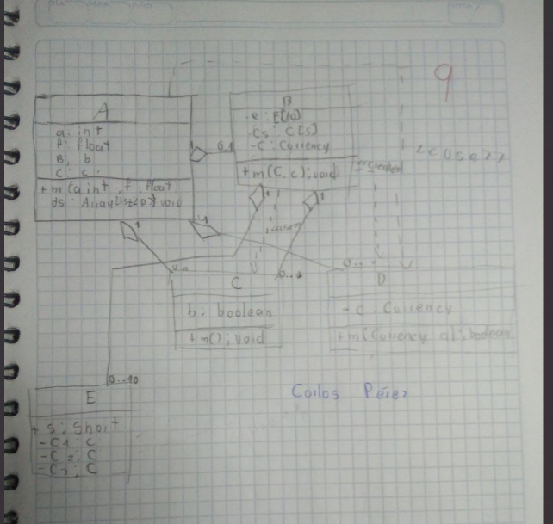

18 TRAVEZ CACHAGO ALEX ISMAEL

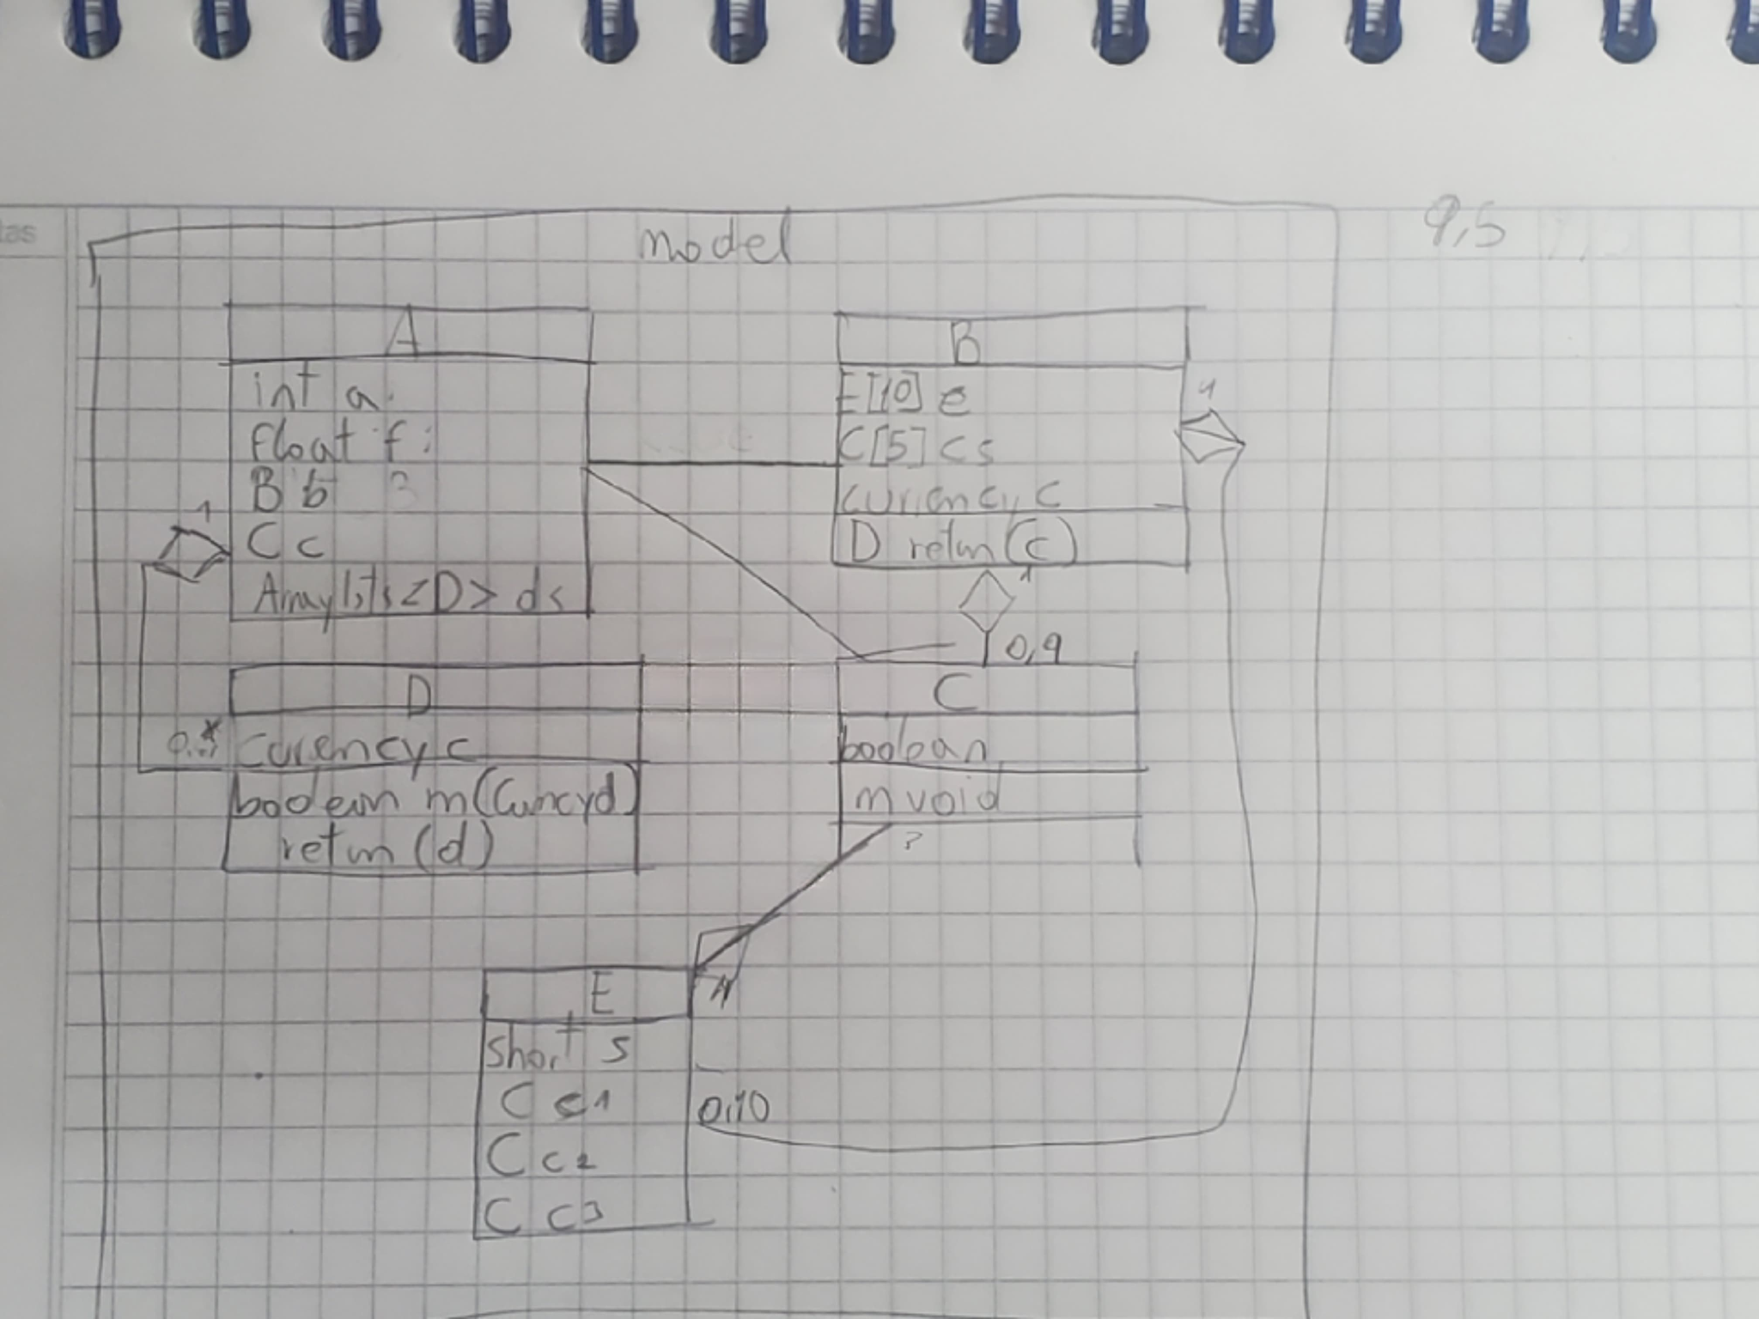

19 RODRIGUEZ VILLAROEL DAVID JOSUE

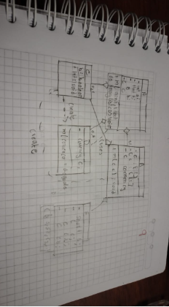

20 SEGARRA DIAZ EDUARDO ANDRES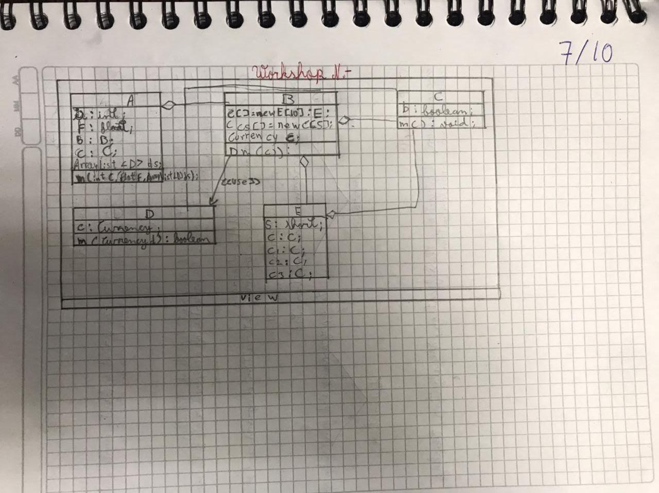

21 VACA ZURITA LUIS EDUARDO

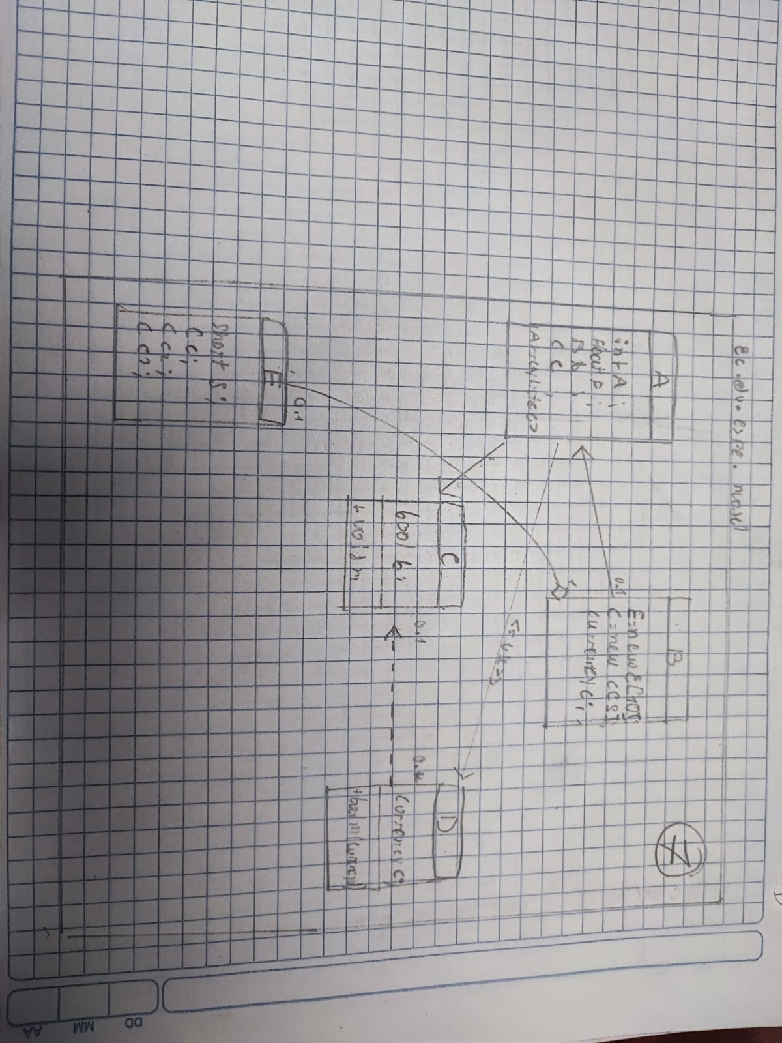

22 VALENCIA BUSTAMANTE YULIANA ANAHI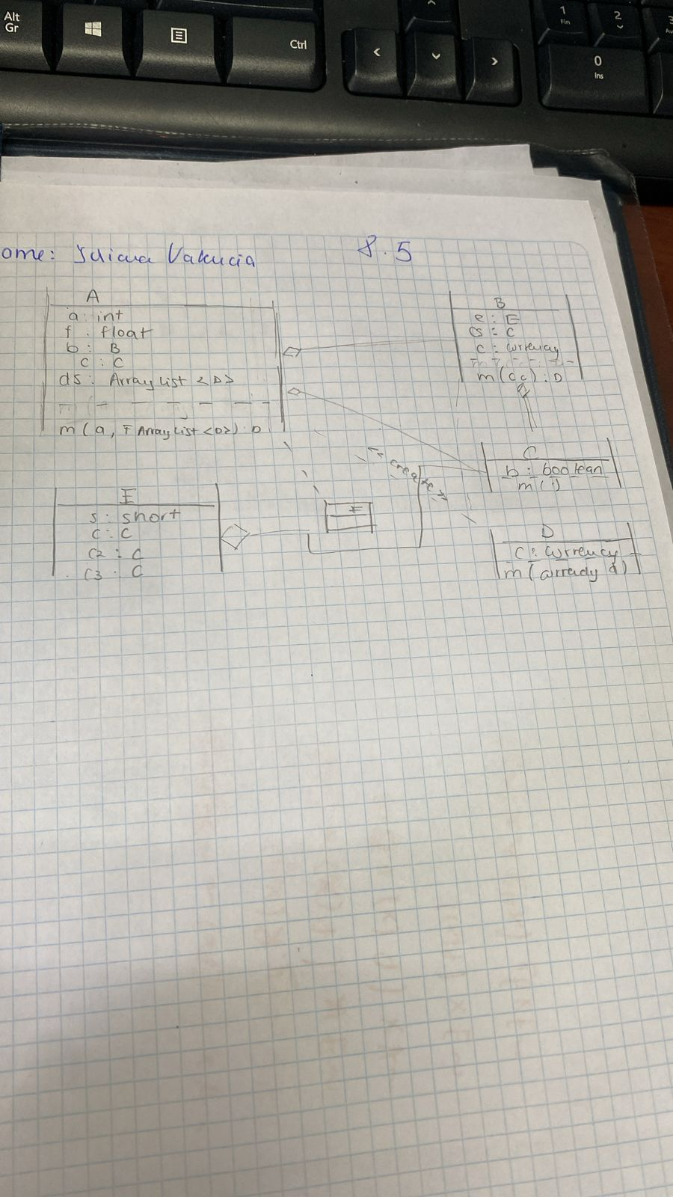

23 VILLAGOMEZ FREIRE DOMENICA NICOLE

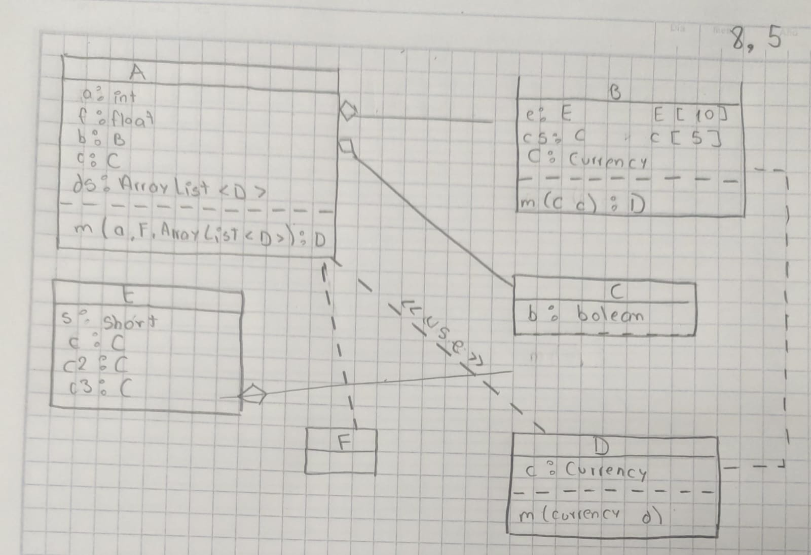

24 VITERI AVILA ALEXIS JHOSUE

